**1) How can you tell a method is a constructor?**

It has the same name as the class and does not have the “void” or “static”.

**2) Would public void cheese() be considered a constructor?**

No, it’s more likely a mutator than a constructor.

**3) Does it make sense to have private or void accessor method?**

I think a private private makes more sense because void would return nothing;moreover, void would turn the accessor to a mutator..

**4) Would public void setName() be a good mutator declaration?**

Yes because this mutator would exclusively just set a name to the variable, besides, just by having void in the method makes it a mutator.

**5) How can you tell the difference between instance and class variables?**

Instance variables are always declared as private so that only variables of a certain type can access its values. Class variables are all shared by the instance of that class type.

**6) Can we write name = name; and what would it mean?**

You can write it but it would be useless because it would equal itself, instead, we use “this.name = name;” and it sets the name to the parameter.

**7) How can you tell which version of the constructor is being called?**

It depends on the data type that is in the parameter.

**8) What does the . operator do for objects?**

It can “get” or “set” certain values for variables by using other classes’ methods, basically a shortcut to set values to variables or obtain values.

**9) Can you use a loop to implement calcSubTotal?**

I think you cannot because you have to access each type of cheese separately. I cannot think of a loop that can do this, so no.

**10) Can you tell when and where we do the recursion in run()?**

In my code it happens in line 106 with an if-else statement where the user is asked if they want to redo the whole order.

**11) What does this refer to?**

It refers to the program as a whole. If we would run the whole program again.

**12) What should be the value of numCheese when RunShop terminates (i.e., the output of the println statement)?**

It depends, if you run the program 1 time perfectly, it always will output 3.

**13) Give the code to implement public void setName(String name) { … }.**

public void setName(String name){

name = newName;

numChesse++;}

**Activity 7.2.3**

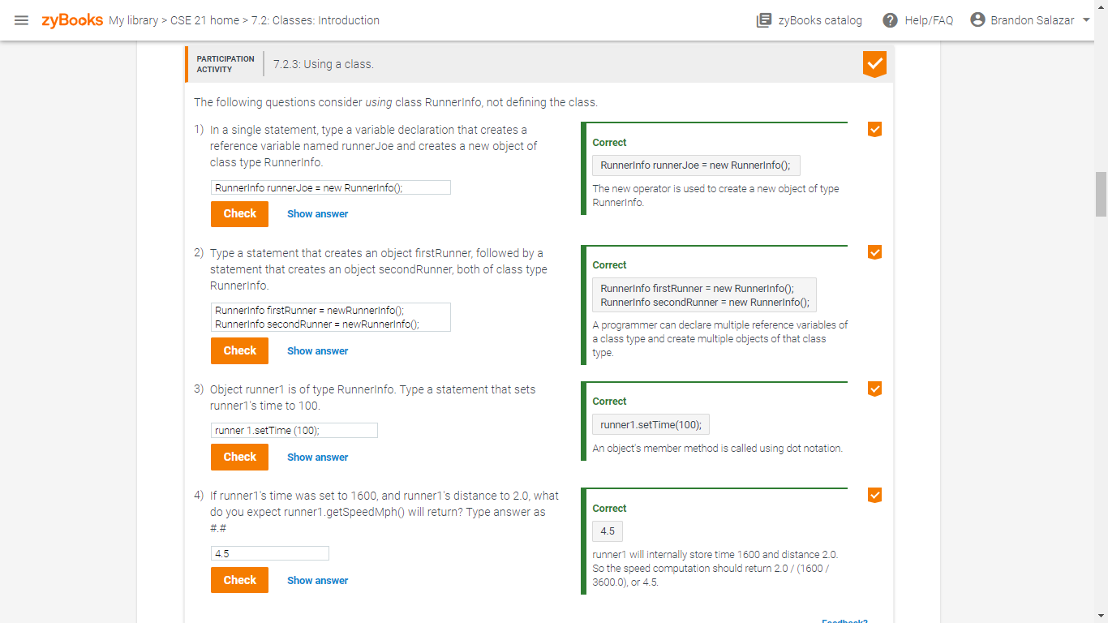

**Activity 7.4.1**

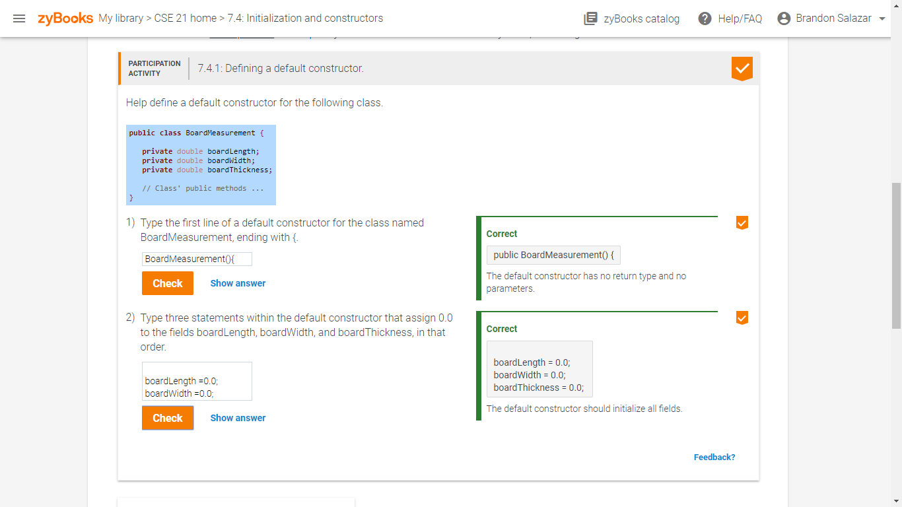

**Activity 7.7.2**

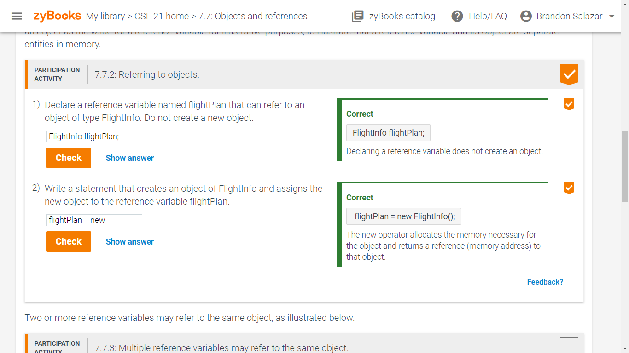

**Activity 7.7.4**

